SCCM Support Desk Toolkit
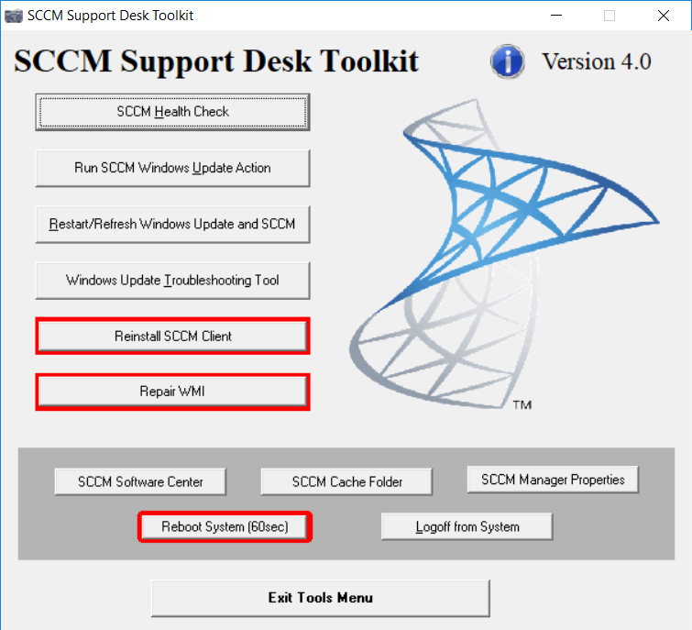

Objective and overview
The objective of this tool is to provide a user friendly toolkit to all support staff.
The initial objective is to assist with Windows Updates and patching of systems.
The tool provide buttons that would run scripts to perform tasks to try and resolve issues. This should address most issues during installation, be it to initiate a scan or having to reinstall the SCCM client.

The toolkit screen is broken up into 2 parts.
The buttons on the light gray would launch scripts to fix issues
The buttons on the dark gray would open SCCM clients on folder, or allow to logoff and reboot.

SCCM Health Check
This button does a few check. It checks if the SCCM client is running and that it was able to get a management point.
It also checked if the server is pending a reboot
Additionally it checks ports to see if the client is able to communicate with the SCCM server.
And lastly it check/opens BITS to monitor downloads to the system

Run SCCM Windows Update Action
This would run through the SCCM tasks, initiate the scan for policies, updates and what is applicable to the system
It would open the UpdatesStore log to view activity of the scan

Restart/Refresh Windows Update and SCCM
WARNING – This process would reset policies and can take up to 24 hours to update
This process will reset policies of both Windows Updates and SCCM client.
It will also clear the cash for both Windows Updates and SCCM client.

Windows Update Troubleshooting Tool
This will launch the Microsoft Troubleshooting Tool for the specific OS

Reinstall SCCM Client
WARNING – This process would reset policies and can take up to 24 hours to update.
WARNING – This process can’t be used on SCCM servers, secondary site or distribution points.
This would uninstall SCCM client. Clear out the policies and registry keys for SCCM. Clear out all the folders for SCCM. And then reinstall SCCM.

Repair WMI
WARNING – This process can’t be used on servers.
A script would be launch the re-register the DLLs of WMI and restart the services.

SCCM Software Center
Button would open up SCCM Software Center

SCCM Cache Folder
Button would open up SCCM Cache folder. Normally C:\Windows\CCMCache

SCCM Manager Properties
Button would open the SCCM properties from the control panel

Reboot System
This would trigger a system reboot, allowing 60 seconds before it reboots

Logoff from System
This would log you off from the system

